**REPORT**

Kritica Arora - 2105551

Arghya Roopam Behera - 21051720

Subhasis Swain - 21052201

**Classification of Vowels from Imagined Speech with Convolutional Neural Networks**

Imagined speech is used to allow physically impaired patients to communicate and to use smart devices by imagining desired commands and then detecting and executing those commands in a smart device. This research uses a data set that consists of 15 subjects imagining saying the 5 main vowels and 6 different words.

Imagined speech decoding process consists of three phrases: **(I)Pre processing (II) Feature Extraction (III) Classification.**

**Pre processing** is essential since imagined speech signals have a low signal-to noise ration.The data set undergoes various pre processing steps such as (a) Artefact Removal (b)Band-pass filtering.

In **Methodology**, we use in this project Convolutional Neural Network which further consists of filters which determines the result.This neural network consists of an initial convolution block followed by several separately viewable convolution blocks.

The CNN model consists of input layer, two 2D convolutional layers, one for *temporal* and one for *spatial* convolution which consists of filters , as well as a batch normalization used for speed up using rescaling and Relu activation layers. Following that, there are two identical convolution, both of them consisting of the following: 2D convolution, batch normalization, Relu activation, average pooling, and dropout to prevent overfitting . The final classification part consists of a dense layer followed by a softmax classification layer. The model was implemented in Python with Keras and Tensorflow frameworks

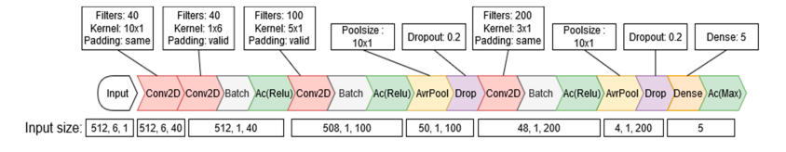

Figure describes all of the layers along with their parameters.

**RESULT**